
CY 104L– Introduction to Cybersecurity
lab # 06
Windows Security

BS ESS – F26 – 1A
––
Student Name: Athar Imran
Student ID: 2604277

Assignment Date: 11 October, 2026
Assignment done: 11 October, 2026
Due Date: 15 October, 2026

Windows Security Settings

Window Update:
Windows must be updated regularly as it helps protection against latest know threat and it comes with the patch of known vulnerabilities in previous versions. If kept not updated will risk PC to a windows-based attack.
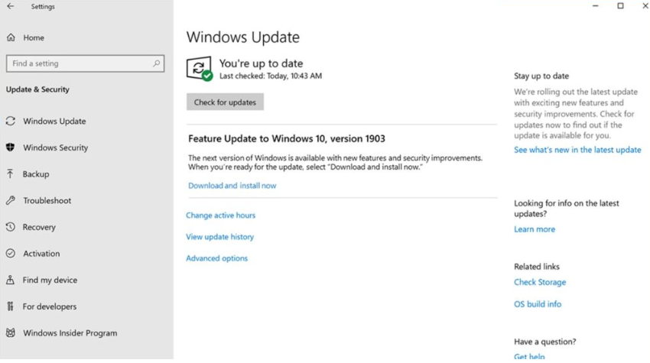

Strong Authentication:
Windows or any OS must be protected with the password that is strong and unguessable. This strong authentication helps to avoid risk of unauthorize access.
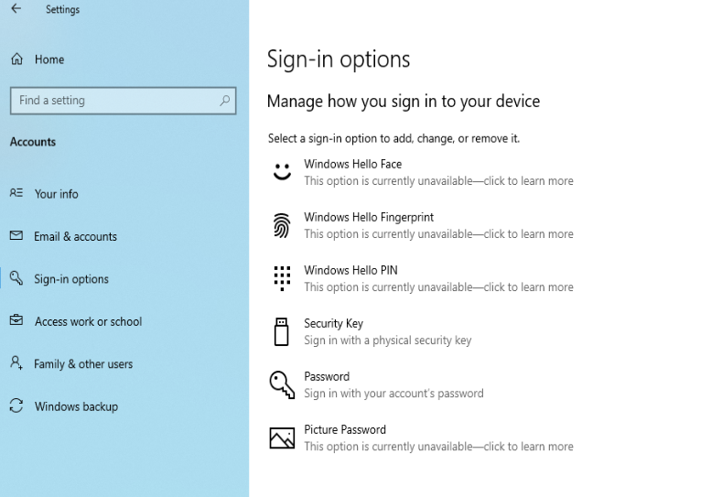

Disable Unnecessary Services:
Each program comes with a service that run in background and aids to program to function. Few programs are necessary and sometimes malicious, there services must be disabled so that they would not function properly and thus protecting PC from malware.
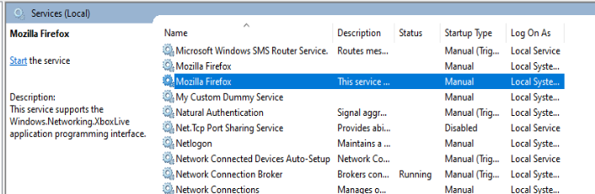

Set up Microsoft Defender:
Windows comes with a default Anti-Virus, called MS Defender. It must be setup all the time, as it comes with the known windows viruses & malware’s signature, thus any file or service matches the signature that are pre-built in Defender will be blocked immediately. .
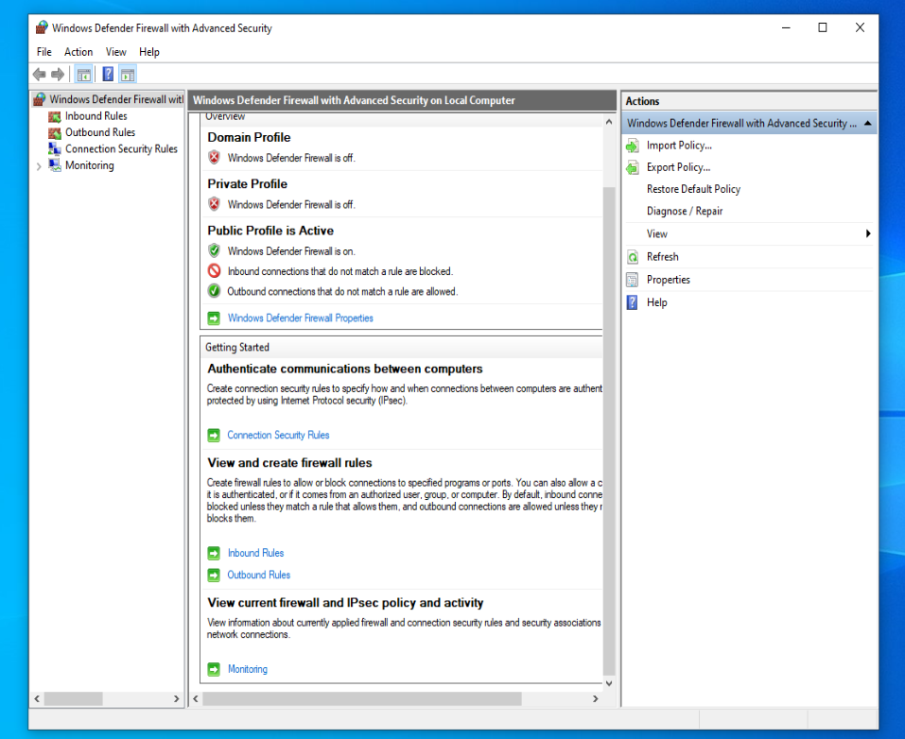

Permissions audit:
Program in windows need permission to access certain services and privileges, malware programs always tries to escalate privileges and attain its malicious services in the windows, thus permission must be checked regularly to avoid malware enjoying higher privilege.
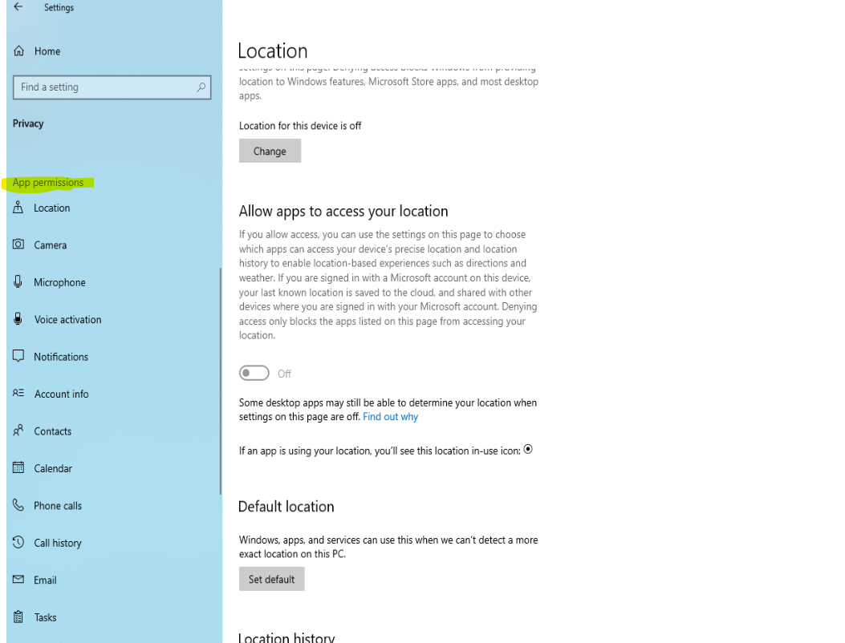

Privacy settings:
Windows collects a lot of personal data that is sometimes not meant to be collect, thus privacy checking regularly will avoid any privacy threat from windows.
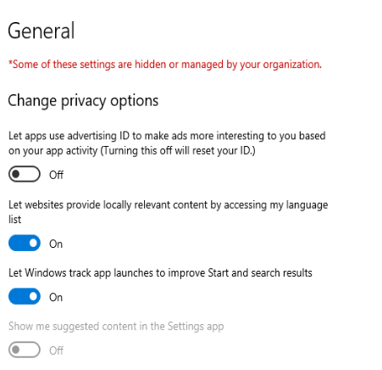
User Account Control (UAC):
It helps each user to maximum and ensure their control on their own account. It notifies the user if any change is made to windows that are not in the knowledge of that user.
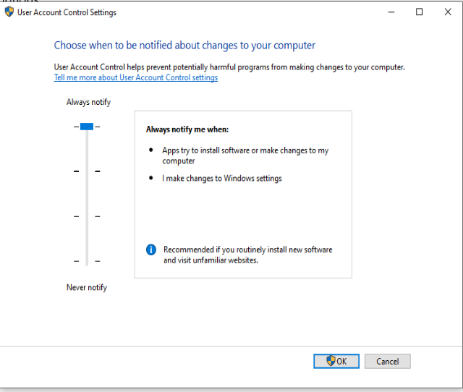

Password and Account Policies:
Passwords must be at least 8 digit characters. This can be adjust with the setting below. Each user on the PC must set their own secure password.
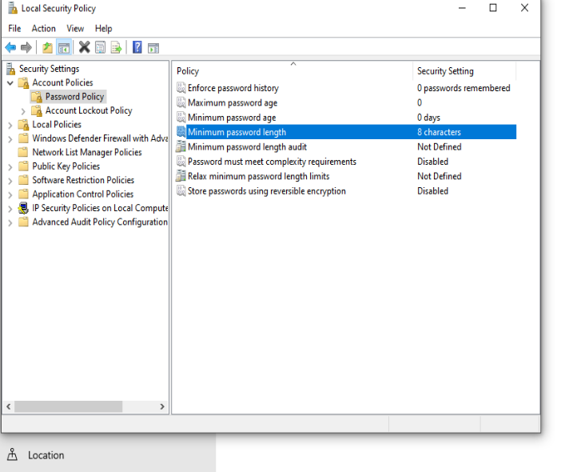
User based folder permissions
This setting is configured by admin for globally in windows and each user can set their own setting for their personals files & folder. Users must set permissions of their sensitive folders knowingly to avoid any confidential risks.
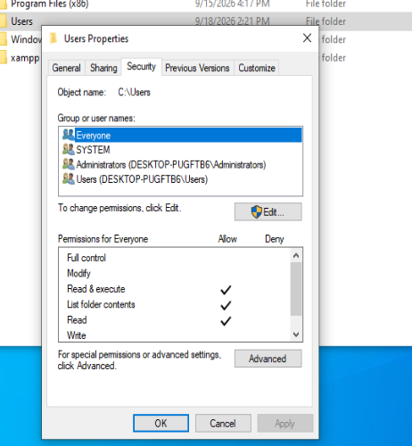
File encryption:
Certain that require strong protection and are store inside PC must be encrypted to avoid any integrity and confidentiality risk. Encrypting file allows users to store files for long and secure.
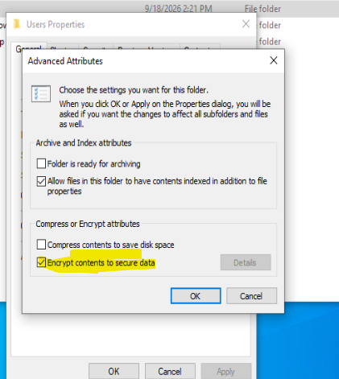

Firewall Configuration:
Alongside MS Defender windows also have a firewall, that must be configured, it helps any malicious network traffic enters inside the systems. It also blocks the harmful pings and other scanning that are made for recon.
